Reading tips for families

When reading a book to your child and talking about it together, please find below some tips to help you enjoy books and share the love of reading as a family.

How to read a story to your child

If you can find the time beforehand, read the book to yourself first, so you can think about how you’re going to read it to your child.

On the first reading:
• Make reading aloud feel like a treat. Make it a special quiet time and cuddle up so you can both see the book.
• Show curiosity about what you’re going to read: ‘This book looks interesting. It’s about an angry child. I wonder how angry she gets…’
• Read through the whole story the first time without stopping too much. Let the story weave its own magic.
• Read with enjoyment. If you’re not enjoying it, your child won’t.

On later readings:
• Let your child pause, think about and comment on the pictures.
• If you think your child did not understand something, try to explain: ‘Oh! I think what’s happening here is that…’
• Chat about the story and pictures: ‘I wonder why she did that?’; ‘Oh no, I hope she’s not going to…’; ‘I wouldn’t have done that, would you?’
• Link the stories to your own family experiences: ‘This reminds me of when …’
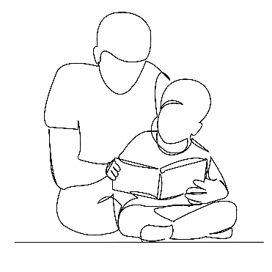
• Link story to other stories that your child knows: ‘Ah! Do you remember the magpie in ….? Do you remember what happened to him?’
• Encourage your child to join in with the bits they know.
• Avoid asking questions to test what your child remembers.
• Avoid telling children that reading stories is good for them.
• Read favourite stories over and over again.

If you have any questions, please ask your child’s teacher.

Please turn over for 10 top tips when reading with your child.

This leaflet has been produced with information from the Government’s ‘The Reading Framework’ (July 2021) and ‘10 top tips for parents to support children to read’ (July 2020) and Leicester libraries ‘Top tips to get your child reading’

Ten top tips when reading with your child

1. Encourage your child to read
Reading helps your child’s wellbeing, develops imagination and has educational benefits too. Just a few minutes a day can have a big impact on children of all ages.

2. Read aloud regularly
Try to read to your child every day. It’s a special time to snuggle up and enjoy a story. Stories matter and children love re-reading them and poring over the pictures. Try adding funny voices to bring characters to life.

3. Encourage reading choice
Give children lots of opportunities to read different things in their own time - it doesn’t just have to be books. There’s fiction, non-fiction, poetry, comics, magazines, recipes and much more.

4. Read together
Choose a favourite time to read together as a family and enjoy it. This might be everyone reading the same book together or reading different things at the same time!

5. Create a comfortable environment
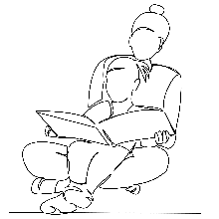
Make a calm, comfortable place for your family to relax and read independently - or together.

6. Make use of your local library
Visit your local library and explore all sorts of books and reading ideas for free!

7. Talk about books
Start by talking about what you can both see on the front cover – what do you think the book is about? Then talk about what you’ve been reading and share ideas. You could talk about something that happened that surprised you, or something new that you found out. How does this book make you feel? Does this book remind you of anything?

8. Bring reading to life
Would you recommend the book to a friend? You could play a game where you pretend to be the characters in the book!

9. Engage your child in reading in a way that suits them
You know your child best and you’ll know the best times for your child to read and be read to. If they have special educational needs and disabilities (SEND) then short, creative activities may be the way to get them most interested. If English is an additional language, encourage reading in your child’s first language, as well as in English. What matters most is that they enjoy it.

10. Make it fun!
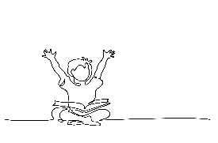
We all learn more when we are enjoying ourselves A happy 10 minutes is better than a difficult half an hour of reading.

